#2.1.e Clickup Screenshots

### Priority Keys:

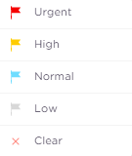

### Subtasks:

## Start of the sprint #2

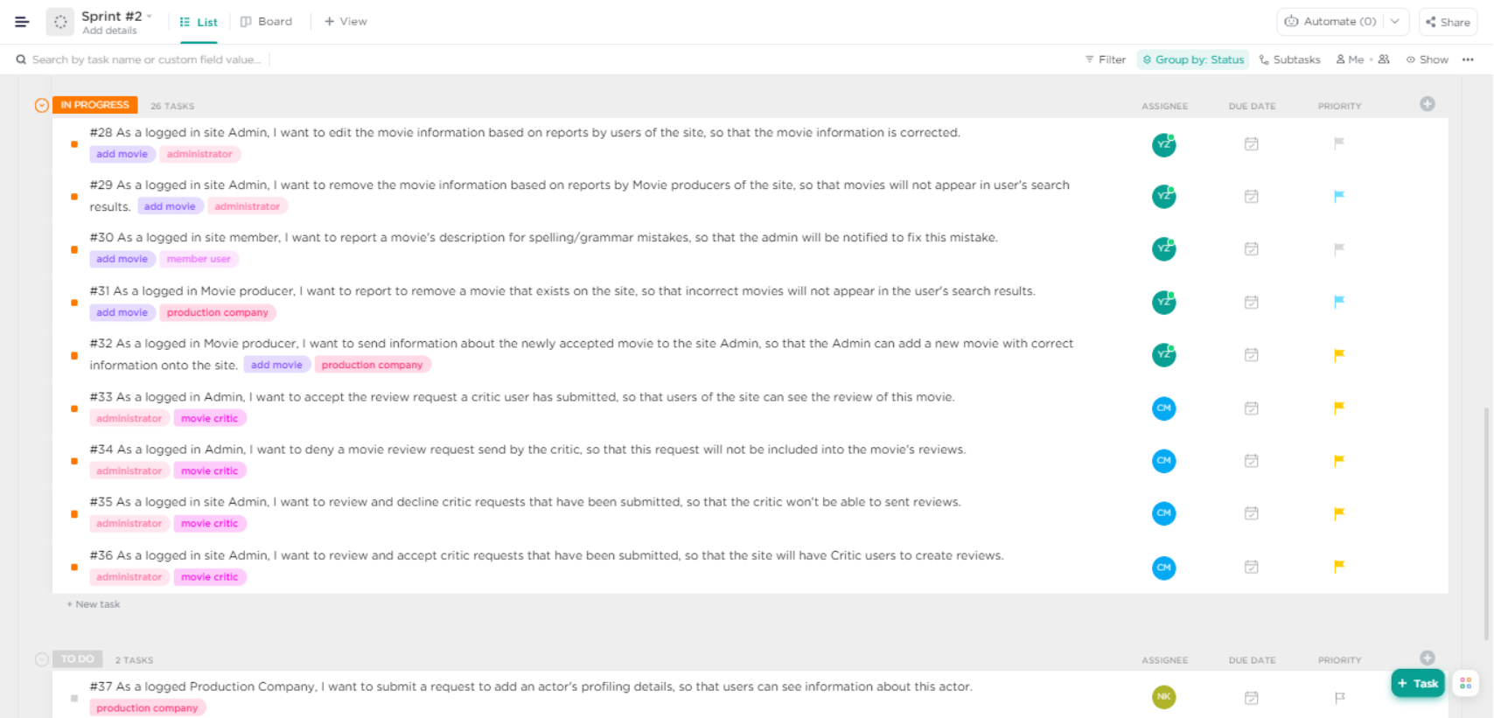

All Tasks to be done are moved into ‘In progress’ to be separated from User Stories not to be completed in this sprint. List View.

Note that for delete and edit movies changed priority to high from Normal Priorities.

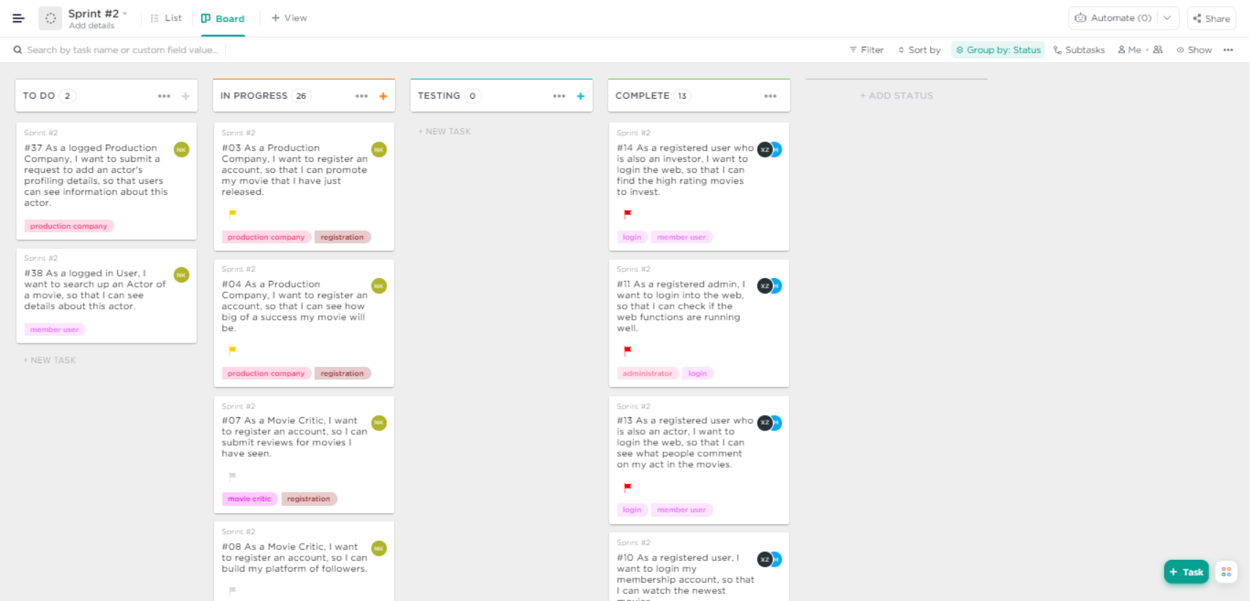

Same as above image, Board View.

## Mid-way the sprint

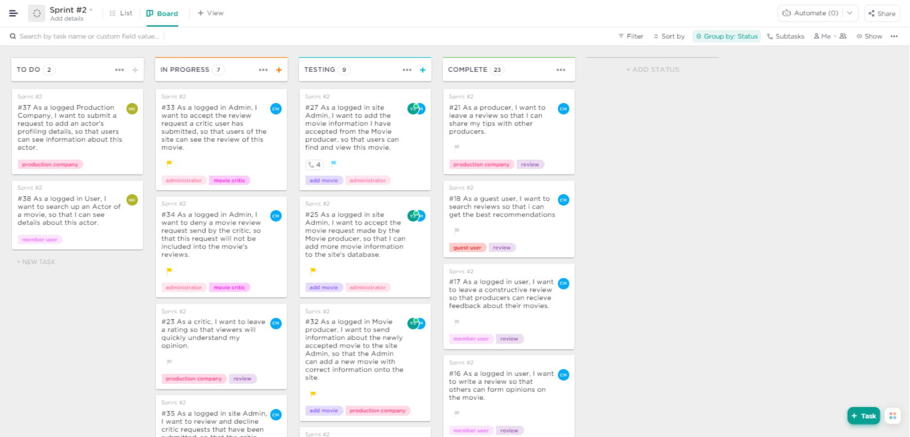

The ‘Movie Information’ feature was being worked on near completion, therefore moved to the Testing column to be tested.

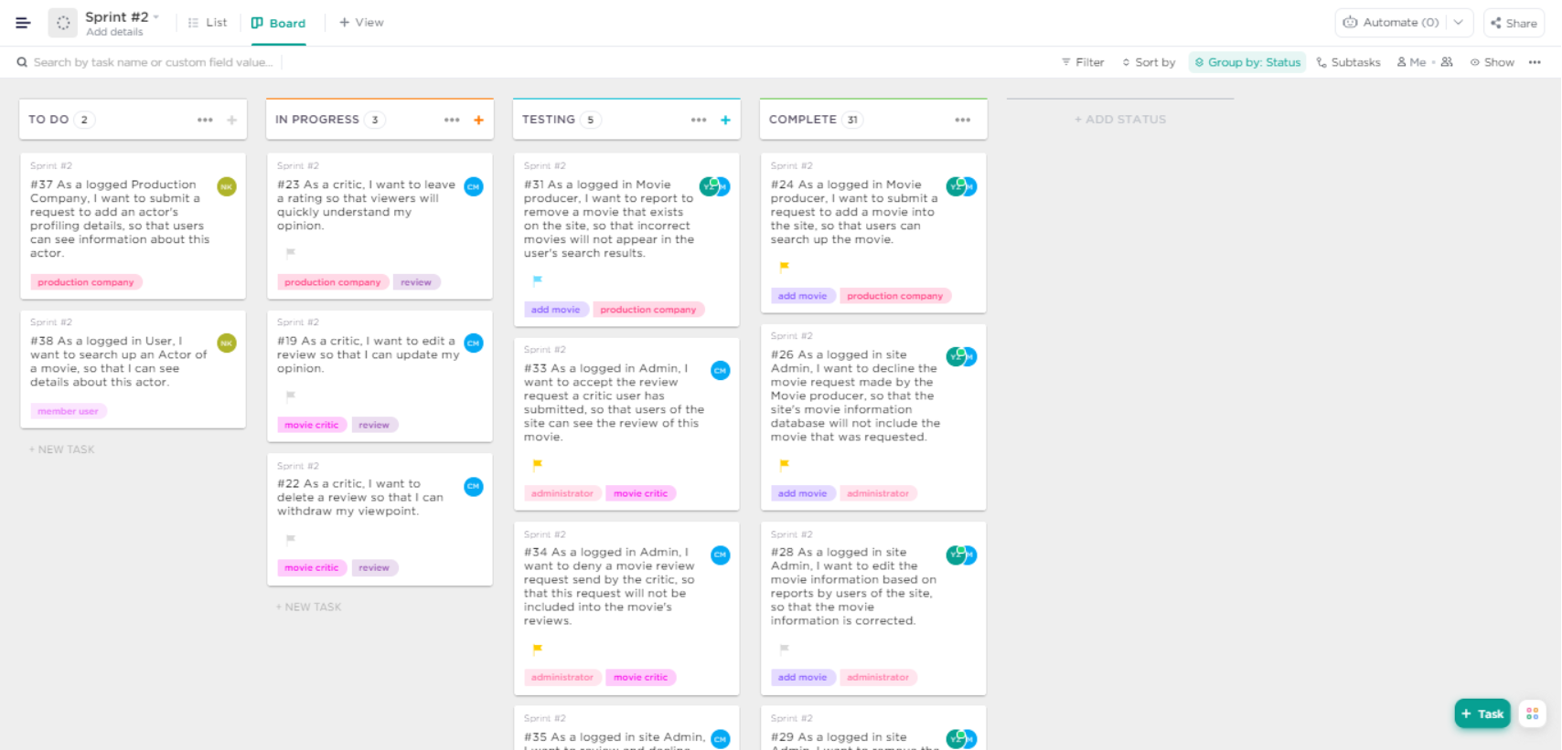

At this midpoint ‘Movie Information’ had a user story to test. ‘Critic Request’ was also being worked on therefore some user stories have progressed to the Testing phase.

## End of the sprint

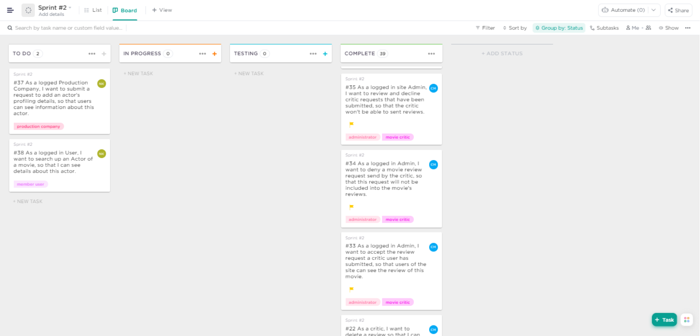

Completed features are in the complete column.

## Inside different cards

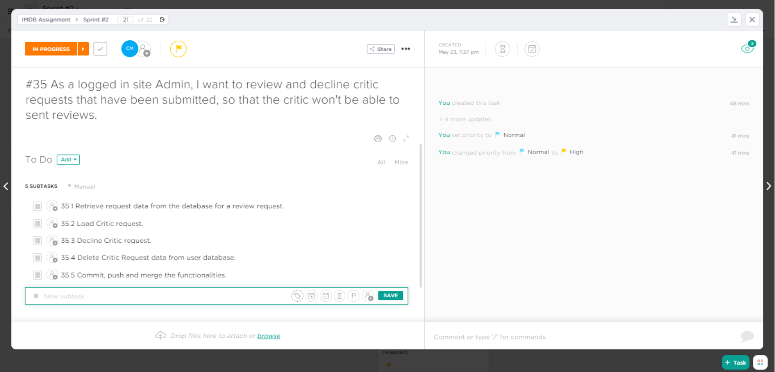

A card on the feature ‘Critic Request’ in InProgress phase. Subtasks are not complete.

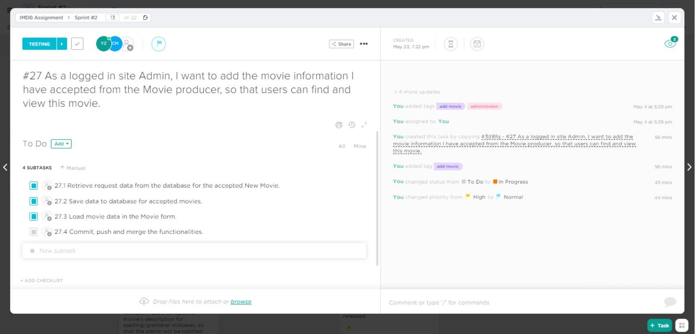

A card on the feature ‘Movie Information’ in Testing phase. Some subtasks are complete and the user story is awaiting to be Pushed.